**Lab Exercise 8– Creating Service in Kubernetes**

Below is a lab exercise that will help you understand and practice creating a service in Kubernetes:

**Task 1: Start Kubernetes in Docker-Desktop**

* Start Kubernetes service in Docker-Desktop

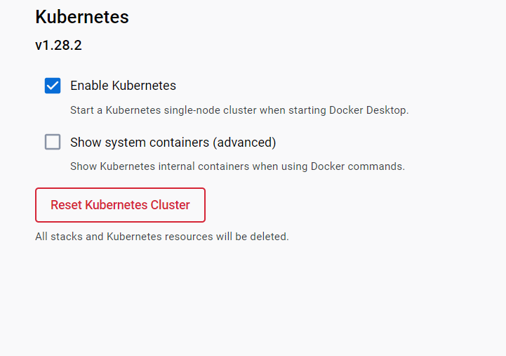

**Task 2: Creating a Service**

Create a service to expose the deployed application within the Kubernetes cluster. You can use the following sample YAML manifest as a reference:

apiVersion: v1

kind: Service

metadata:

  name: my-service

spec:

  selector:

    app: lbnginx

  ports:

  - protocol: TCP

    port: 80

    nodePort: 30001

  type: NodePort

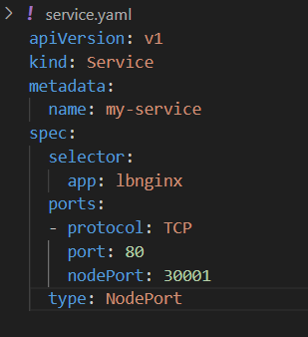

* Apply the service using the following command:

kubectl apply -f service.yaml

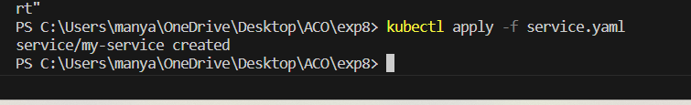

* Verify that the service is created by running the following command:

kubectl get services

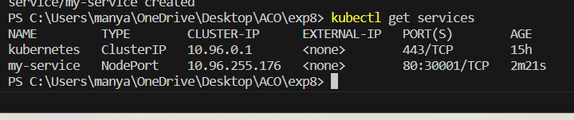

**Task 4: Accessing the Service**

* Access the service using port forwarding. Run the following command:

Access the Nginx server running in the service by opening a web browser and navigating to

http://localhost: 30001

**Task 5: Deleting the Service**

Delete the service using the following command:

kubectl delete service my-service

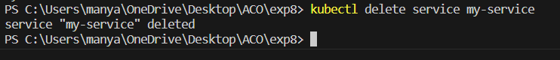

Verify that the service has been deleted by running the kubectl get services command.

**Task 6: Cleanup**

Delete any remaining deployments, services, and resources created during the exercise using the appropriate kubectl delete commands.

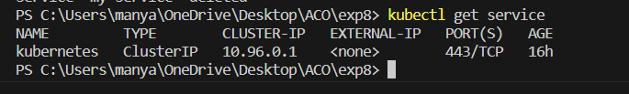

**Task 7: Documentation and Best Practices**

Document your findings and the best practices for creating and managing services in Kubernetes.

Through this exercise, you'll gain a better understanding of how to create and manage services to expose applications within a Kubernetes cluster. Adjust the exercise based on your specific use case and requirements.